Escape report GSP 869 (incomplete).
The aircraft took off from Marham at approximately 20:30.
Three men lost their lives: the pilot, W/O John George Smith, 23; the gunners Sgt William John Sharpe, 20; and Sgt Leslie George Carr, 20. All three were buried at the Heverlee War Cemetery near Leuven/Louvain. Sgt N.J. Mackenzie, RNZAF was taken prisoner.
The aircraft was hit by the Flak over Liège, and the fuselage and hydraulic system caught fire. Jack Cope jumps 6,000 yards and lands in a turnip field. He fails to bury his parachute there and decides to hide it under a pile of leaves.
He walks for three hours in a southwesterly direction, through fields and sometimes along railway tracks, avoiding populated areas. Around 2 o'clock in the morning on 29 August, he rests in a haystack at Folx-les-Caves, about ten km west of Hannut. He wakes up around 5 o'clock and is seen by the farmer’s wife to whom he says: "I am English". The woman brings him into the farm and gives him food. He asked her for the address of the parish priest, but since he was not there, he inquired of other farmers. There, in a more affluent farm, he is fed, receives a full civilian suit and a sum of 1500 Belgian francs. Around 11 a.m., a family member takes him to Brussels where he is put in contact with an organization….
More information here: Comète Line https://www.cometeline.org/fiche054.html

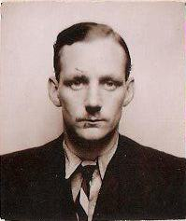 Jack Cope with civilian suit during his escape

