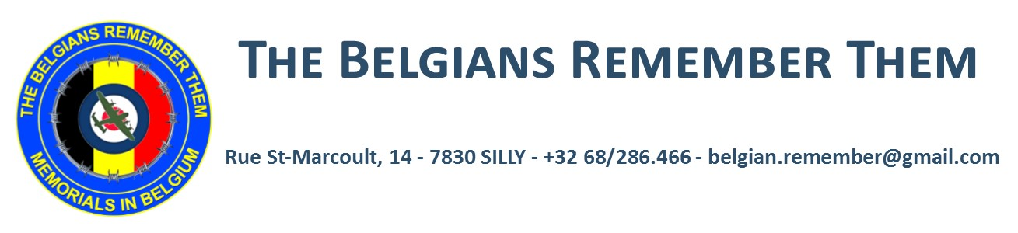
Membership Application Form

Name : _______________________________________________

Address : _____________________________________________
_____________________________________________________
_____________________________________________________

Post code: ______________ Country: _____________________

Email: _______________________________________________

* Membership year starts on 1st January

* Current membership fees are € 15 per annum as Member and € 50 or more as Member Donor per annum

* Payment must be done on the bank Paribas-Fortis account of “The Belgians Remember Them”, IBAN: BE97 0018 3886 3049 - BIC: GEBABEBB – Cheques not acceptable in Belgium

* A newsletter in English language will be sent each 3 months by Email in the form of PDF.

Please, complete this form and return it to belgian.remember@gmail.com to the attention of Wilfred Burie, President
* A certificate of membership will be sent you by return

Your support is vital to our association and
will enable us to continue our duty of Memory!

